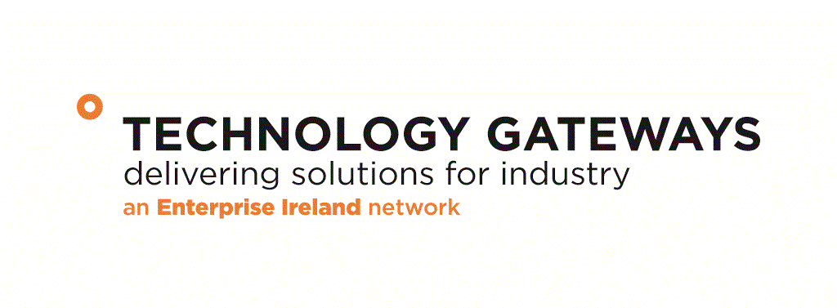

Technology Gateway Programme

Annual Report 2016

Gateway Name
Acronym:
EI Code
Institution:
College Contact:
Position:
Address:
E-mail:
Tel: |  | Mobile:
Gateway Manager:
Gateway Web Link

Current Project Timeframe as Approved
Start Date | 00/00/00 | Completion Date: | 00/00/00
Duration (Months)

Section 1: Personnel

EI Funded Gateway Staff
Position | Name
Gateway Manager
Research Engineer 1
Research Engineer 2
Research Engineer 3
Research Technician
Gateway Staff Funded from Other Sources
Name & Position | Funding Source
Total No of Gateway Staff | Male | Female
Change in No of Gateway Staff from Previous Year
Please comment on how much extra staff have been leveraged by the core EI Gateway team and the impact this has on the Gateway’s technology offer to industry:

Section 2 Industrial Steering Committee
(Please attach in Appendix 1 of this report the minutes of the last industrial steering committee meeting)

Role | Name & Affiliation
Chairperson
Industry Member 1
Industry Member 2
Industry Member 3
Industry Member 4
Industry Member 5
Industry Member 6
EI Representative
IoT Representative 1
IoT Representative 2

Section 3 Industrial Projects

Industrial Projects Completed 2015  (Q4 2014 & Q1-Q3 2015) | Targeted | Achieved This Year
No of projects <€1.5k
No of projects > €1.5k
No of projects > €5k;
No of projects > €10k (innovation partnerships, direct funded etc)
Total € Value of Projects
(as reported finished within year)
Total Industry Contribution
Total Income from Industry
(inclusive of completed projects, FP7 SME, overseas companies & projects < €1,500)
No of Licenses of IP / know how to industry
No. of Industry Referrals to other Gateways
No. of Collaborative Projects with Other Gateways / Research Groups
Additional Summary Information:

Ongoing Projects 2015 | Total No.
No of projects <€1.5k
No of projects > €1.5k
No of projects > €5k;
No of projects > €10k (innovation partnerships, direct funded etc)
Total € value of projects
Total Industry Contribution
No of Licenses of IP / know how to transferred to industry
Additional Summary Information:

Please provide summary details in the following Table on Gateway Completed Projects in this Year and in Appendix 2 Selected Industry Approved Case Studies
Company  Name | Total  Project Value  € | Funding Source(s)* | Start /  End Date | Brief Project Description | Brief Project Outcome**
* EI Innovation Vouchers, Innovation Partnerships, Direct Funded Industry, etc
** Issued solved, new product developed, licence agreement, jobs created, etc
Section 4 Development of Industrial Project Pipeline

Target Company | Target Project Area | Prospect For Conversion  % | Project Value  € | Contact Name | Date of Visits | Proposal Submitted Y/N? | Project  Secured

Section 5 Technology Themes-Activity Summary

Technology Theme | Key Benefits to Industry | Completed Projects with the following companies: | Ongoing Projects with the following companies: | Pipeline Projects with the following companies:

Section 6 Gateway Promotion Strategy:

Promotional Tool | Summary Description of Activity
Industry Days
Information Seminars
Training Events for Industry
Industry Network / Associations
Web Site Development
Media Exposure
Trade Shows Attended
Conferences Attended
Another
Please Provide Summary Details of the Impact of the Promotional Activities in Enhancing the Industry Engagement of the Gateway

Section 7 Applied Research Activities

Applied Research Projects Completed 2015  (Q4 2014 + Q1-Q3 2015) | Targeted | Achieved To Date
€ value of state research funding
i.e. EI Commercialisation Fund; SFI
€ value of other non-exchequer funding i.e. Horizon 20/20
€ value Other
Peer Reviewed Publications
Measures of IP generation (invention disclosure forms, patents filed, etc)
No of collaborative projects
Other
Additional Summary Information: i.e. Pipeline of New Proposals, Summary details of projects secured during TG funding, and commercialisation path for each project.

Section 8 Progress Vs Targets

Briefly Outline Any Issues Challenges Affecting the Performance of the Gateway and specifically each of the Technology Themes.
What strategic initiatives will the Gateway undertake in Year 2 to enhance the Gateway’s performance?

Section 9 Financial

 | Pay | Capital | Promotion | Travel  (Dom) | Travel  (OS) | Total
EI Grant
Cumulative Spend
Balance

Confidentiality:

All of the information provided will be confidential to Enterprise Ireland and any agents it appoints for evaluation purposes.
FOR OFFICE USE ONLY

Date Received: ___________________ Referral To: _____________________ Date: ____________
Cleared By: ___________________ Internal Evaluation: No □ Yes □
Approved By:

Appendix 1 Minutes of This Quarter Industrial Steering Committee Meeting

Appendix 2 Case Studies

Case Study Template (Company Approved Completed Industrial Project)

Company Name:
Funding Source & Value:
Project Title:
Profile of Company:

Problem to Be Solved:

How Gateway Delivered Solution for Industry:

Impact for the Company

Company Testimonial

