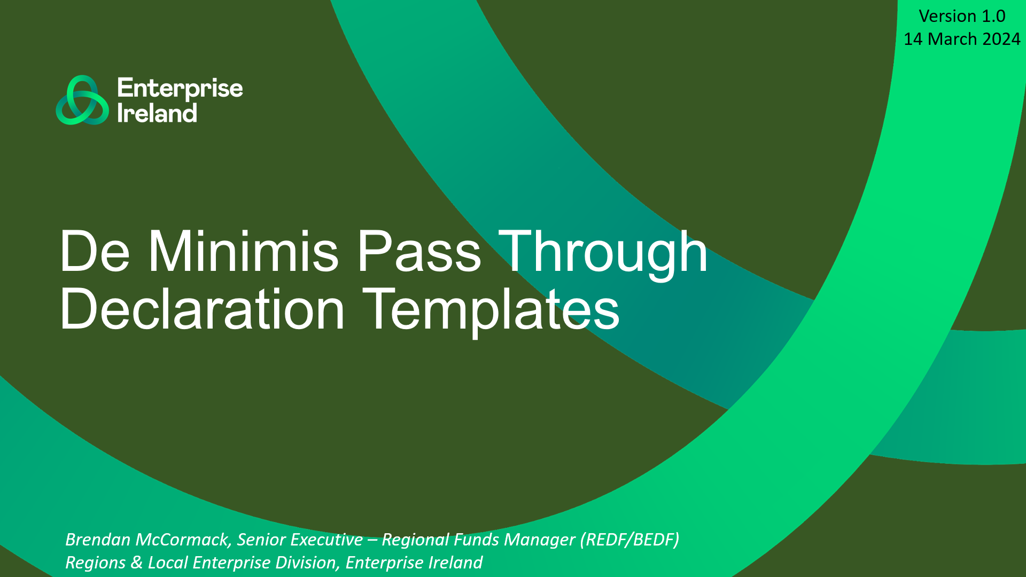

Version 1.0 – 14 March 2024

This document has been created to support Regional Enterprise Development Fund (REDF) or Border Enterprise Development Fund (BEDF) funded Intermediary DAC/CLG Companies to use the proper wording on all invoices to correctly pass through De Minimis Grant amounts to Beneficiary Companies.

The document, in section 2, also includes a De Minimis Declaration Template which should be completed by each Beneficiary Company and returned to the REDF/BEDF funded Intermediary Company at least once per year. Declarations should be kept on file to confirm that beneficiaries of De Minimis grant support do not exceed the €300,000 threshold as set out in EC Regulation No. 2831/2023 of 13 December 2023.

**1. Wording to be used on all Invoices that include a De Minimis Grant offer:**

***Declaration:*** *By paying the amount above the payee company hereby declares that it has sufficient Under-Threshold De Minimis balance available. Payment also confirms that the Beneficiary Company accepts the De Minimis Grant amount as De Minimis state support from the date of this invoice. Otherwise the payee must pay the full market value of the goods & service provided and no De Minimis will be passed through.*

***Disclaimer:*** *The De Minimis Grant applied to the goods & services on this invoice constitutes state aid. This support is provided as De Minimis Aid under EC Regulation No. 2831/2023 of 13 December 2023.*

**2. De Minimis Declaration Template to be completed by ALL Beneficiary Companies:**

*(Template to be edited into a new document for completion by beneficiary companies)*

Please complete this declaration of any previous De Minimis Aid received, as required under [Commission Regulation (EU) 2023/2831 of 13th December](https://eur-lex.europa.eu/legal-content/EN/TXT/HTML/?uri=OJ:L_202302831) 2023 (**“De Minimis Regulation”**).

**[ INSERT NAME OF REDF/BEDF FUNDED INTERMEDIARY COMPANY ]** (the Intermediary) will assess your eligibility for support based on the information in this declaration.

**Declaration**

I, the undersigned, being an authorised representative of **[ INSERT NAME OF BENEFICIARY ENTITY ]** (the Beneficiary)declare that **[ INSERT NAME OF BENEFICIARY ENTITY ]**, together with all other entities considered a ‘single undertaking’ within the meaning of Article 2(2) of the De Minimis Regulation[1], and together with any merged or acquired undertakings within the meaning of Article 3(8) and after having considered the treatment of previous De Minimis Aid following the split of the undertaking in accordance with Article 3(9) if any;

*(Please tick the relevant box and where appropriate, complete the table provided)*

**have not benefited** from any De Minimis Aid in the last three years;

**have** **benefited** from the following aid under the existing De Minimis regimes in the last three years:

|  |  |  |  |  |  |
| --- | --- | --- | --- | --- | --- |
| **De Minimis Aid** | | | | | |
| Please include all De Minimis Aid received in the last 3 years, including any De Minimis Aid provided to a linked enterprise, e.g. any group or controlled undertaking and De Minimis Aid received by any merged or acquired undertakings: *(add additional lines if/as required)* | | | | | |
| **Date of granting of support** | **Organisation granting the De Minimis Aid** | **Beneficiary of the De Minimis Aid** | **Aid Type** (grant, loan and/or other aid instrument | **Amount of De Minimis Aid** (gross grant equivalent)  **€** |
|  |  |  |  |  |
|  |  |  |  |  |
|  |  |  |  |  |
|  |  |  |  |  |
|  |  |  |  |  |
|  |  |  |  |  |
|  |  |  | **Total** |  |

**I acknowledge** that untruthful/false declarations will result in recovery of any De Minimis Aid awarded to the Beneficiary by the Intermediary.

**Signature: Date:**

**[ INSERT NAME OF SIGNATORY ]**

**as Authorised Signatory,**

**for and on behalf of**

**[ INSERT NAME OF BENEFICIARY ENTITY ]**

**[ INSERT COMPANY REGISTRATION NO. OF BENEFICAIARY ENTITY ]**

1. **‘Single undertaking’** means, for the purposes of this Regulation, all enterprises having at least one of the following relationships with each other:

   one enterprise has a majority of the shareholders’ or members’ voting rights in another enterprise;

   one enterprise has the right to appoint or remove a majority of the members of the administrative, management or supervisory body of another enterprise;

   one enterprise has the right to exercise a dominant influence over another enterprise pursuant to a contract entered into with that enterprise or pursuant to a provision in its memorandum or articles of association;

   one enterprise, which is a shareholder in or member of another enterprise, controls alone, pursuant to an agreement with other shareholders in or members of that enterprise, a majority of shareholders’ or members’ voting rights in that enterprise.

   Enterprises having any of the relationships referred to in points (a) to (d) through one or more other enterprises shall also be considered to be a single undertaking.